AIM: Use Wire shark to understand the operation of TCP/IP layers:
- Ethernet Layer: Frame header, Frame size etc.
- Data Link Layer: MAC address, ARP (IP and MAC address binding)
- Network Layer: IP Packet (header, fragmentation), ICMP (Query and Echo)
- Transport Layer: TCP Ports, TCP handshake segments etc.
- Application L ayer: DHCP, FTP, HTTP header formats
TOOLS/SOFTWARES REQUIRED: Wireshark
THEORY:
WireShark:
Wireshark is a network protocol analyzer used to:
- Capture network packets in real time
- Inspect packet headers and payloads
- Analyze how protocols work across TCP/IP layers
It allows us to see what actually happens on the wire, instead of just theoretical behavior.

Frame Header and Frame Size (Ethernet)
- In Wireshark, each captured packet appears as a frame, for example Frame 1 or Frame 12.
- The frame header shows the destination MAC address, source MAC address, and the type field.
- Example:
Destination:ff:ff:ff:ff:ff:ff
Source:66:bd:12:b8:77:99
Type: IPv4 (0x0800)
- The frame size indicates the total length of the frame, such as 60 bytes on wire (480 bits).
- This helps analyze how much data is transmitted at the physical level.

MAC Address and ARP (IP and MAC Address Binding)
- MAC addresses appear in Wireshark as hexadecimal values separated by colons.
- Example MAC: 00:0c:29:3e:5a:91
- When an ARP packet is captured, Wireshark shows an ARP Request like:
“Who has IP 192.168.1.1? Tell 192.168.1.5”
- The ARP Reply shows the binding:
“192.168.1.1 is at 00:50:56:c0:00:08”
- This demonstrates how ARP maps IP addresses to MAC addresses in a local network.

IP Packet, Header, and Fragmentation
- In an IP packet, Wireshark displays the IP header fields clearly.
- Examplefieldsinclude:
Source IP: 192.168.1.5
Destination IP: 8.8.8.8
TTL: 64
Protocol: TCP
- If fragmentation occurs, Wireshark shows multiple packets with the same Identification value.
- Fragment offset values indicate how packets are split and later reassembled at the destination.

ICMP (Query and Echo)
- ICMP packets are commonly seen during a ping operation.
- Example in Wireshark:
ICMP Echo (ping) request
Source: 192.168.1.5 → Destination: 8.8.8.8
- The reply appears as:
ICMP Echo reply
Source: 8.8.8.8 → Destination: 192.168.1.5
- These packets confirm reachability and network connectivity.

TCP Ports and TCP Handshake Segments
- Wireshark displays TCP port numbers along with IP addresses.
- Example:
Source Port: 52344
Destination Port: 80
- During connection setup, three packets are visible:
  - SYN from client to server
  - SYN-ACK from server to client
  - ACK from client to server
- These packets together form the TCP three-way handshake, ensuring a reliable connection.

DHCP, FTP, and HTTP Header Formats
- DHCP packets in Wireshark show messages such as DHCP Discover and DHCP Offer.
- Example:
Client requests an IP → Server offers 192.168.1.10
- FTP traffic shows commands like USER, PASS, RETR in the packet details.
- HTTP packets display readable headers.
- Example HTTP request:
GET /index.html HTTP/1.1
Host: www.example.com
- Example HTTP response:
HTTP/1.1 200 OK
Content-Type: text/html

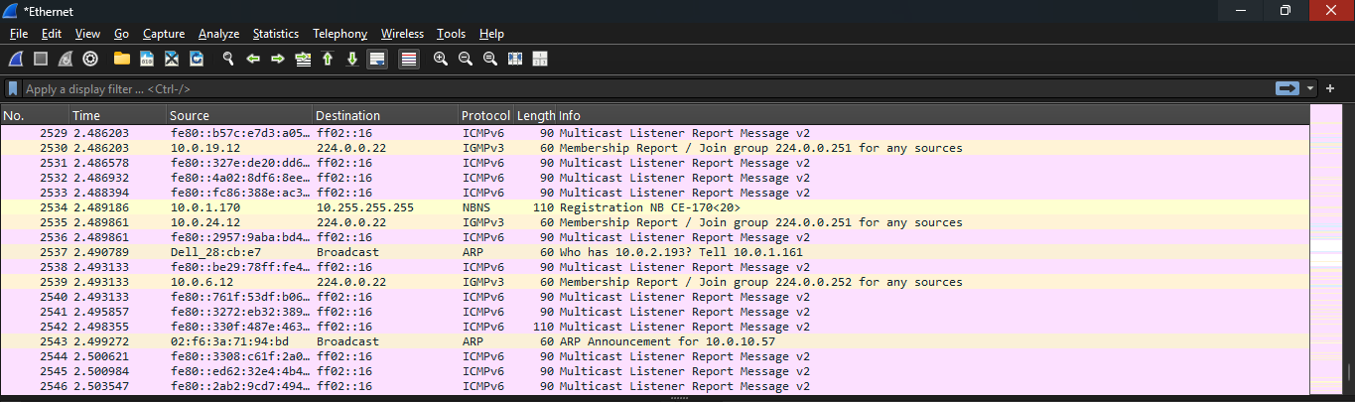
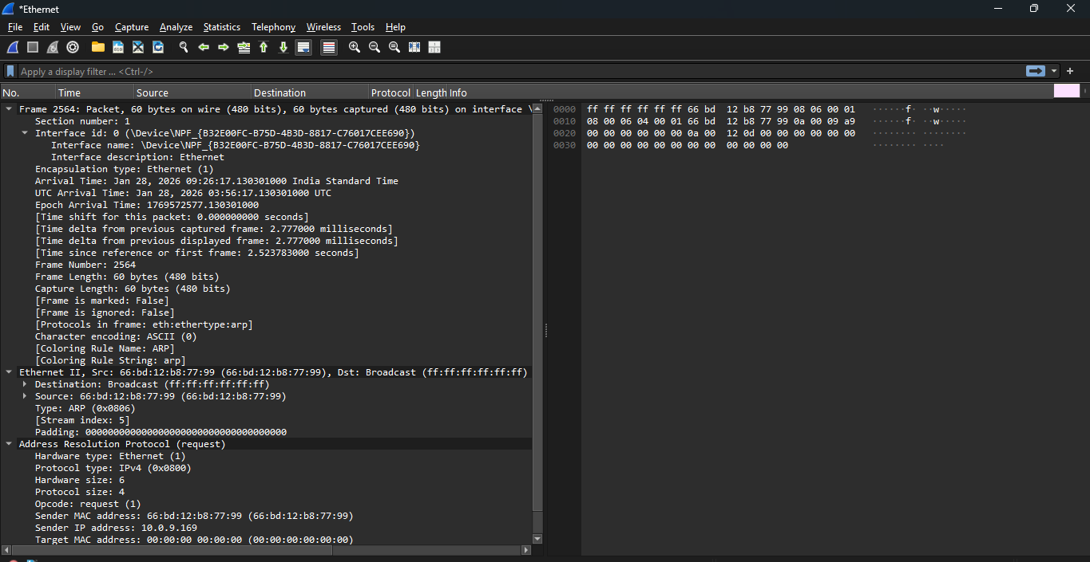

CONCLUSION:
In this experiment, Wireshark was used to analyze and understand the operation of different layers of the TCP/IP model. By capturing live network traffic, the structure and function of Ethernet frames, MAC addressing, and ARP-based IP–MAC binding were observed. The analysis of IP packets provided insight into packet headers, fragmentation, and routing behavior, while ICMP packets demonstrated network diagnostics through echo request and reply messages. Transport layer analysis highlighted the role of TCP ports and the three-way handshake in establishing reliable communication. Finally, application layer protocols such as DHCP, FTP, and HTTP were examined through their packet formats and headers. Overall, this experiment helped in gaining practical understanding of how data is transmitted across networks and how Wireshark can be effectively used for network monitoring and troubleshooting.

